**Experiment: 1**

**Aim:** Write a java program to display the employee details using Scanner class.

**Software:** VS Code

**Code:-**

import java.util.*;

class Employee_Detail

{

    String Name;

    String Post;

    String Location;

    int age;

    int salary ;

}

public class Programm3

{

    public static void main(String args[])

    {

            Scanner sc = new Scanner(System.in);

            Employee_Detail  Employye= new  Employee_Detail() ;

            System.out.print("Enter The Name Of Employee:-");

            Employye.Name = sc.nextLine();

            System.out.print("Enter The Post Of Employee:-");

            Employye.Post = sc.nextLine();

            System.out.print("Enter The Location Of Employee:-");

            Employye.Location = sc.nextLine();

            System.out.print("Enter The Age Of Employee:-");

            Employye.age = sc.nextInt();

            System.out.print("Enter The Salary Of Employee:-");

            Employye.salary = sc.nextInt();

             System.out.println("Employee Details:-\nName:- "+Employye.Name + "\nPost:- " + Employye.Post + "\nLOcation:- " + Employye.Location+ "\nAge:- "+ Employye.age +" Years" + "\nSalary:- Rs " + Employye.salary + " /-");

    }

}

**Output:**

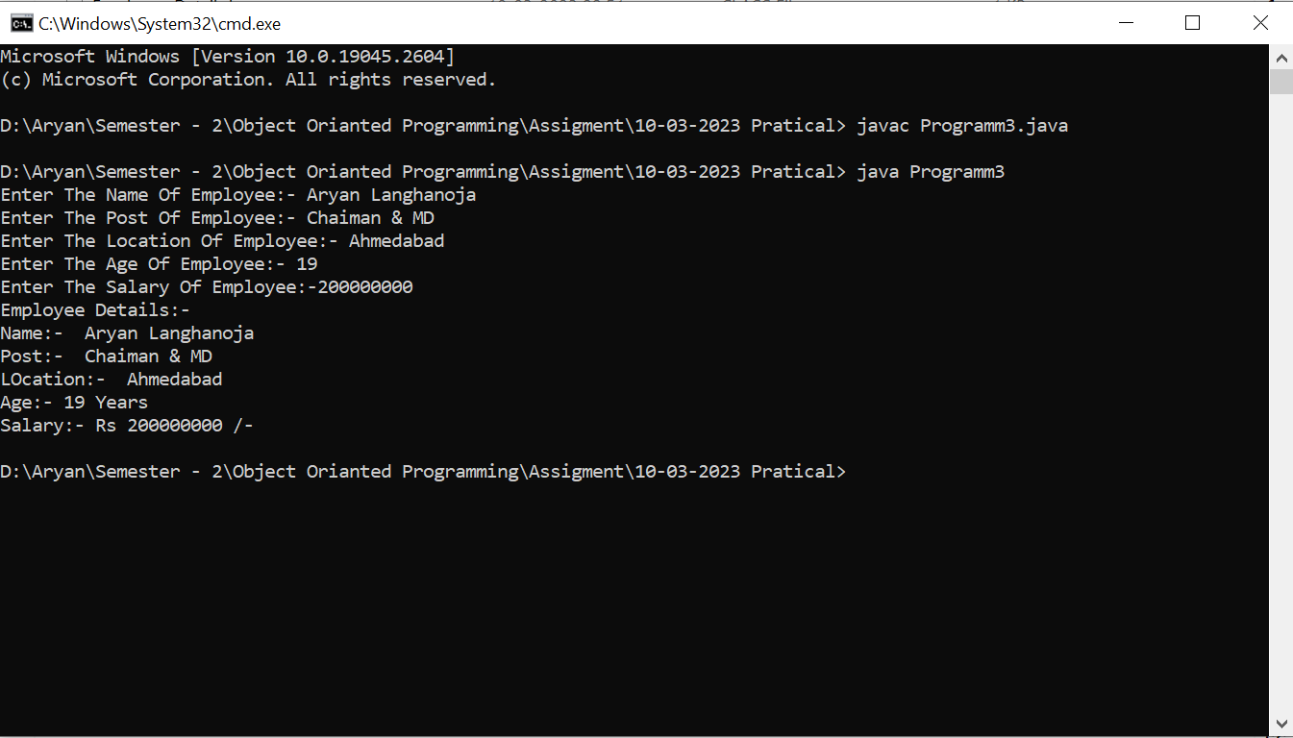

**Experiment: 2**

**Aim:** Write a java program that checks whether a given string is palindrome or not.

**Software:** VS Code

**Code:**

import java.util.*;

public class Programm2

{

    public static void main(String args[])

    {

        Scanner sc = new Scanner (System.in);

        String A,B;

        System.out.print("Enter The First String:-");

        A = sc.nextLine();

        B=new StringBuilder(A).reverse().toString();

        if(A.equals(B))

        System.out.print("Palindrome");

        else

        System.out.print("Not Pelindrome");

    }

}

**Output:**

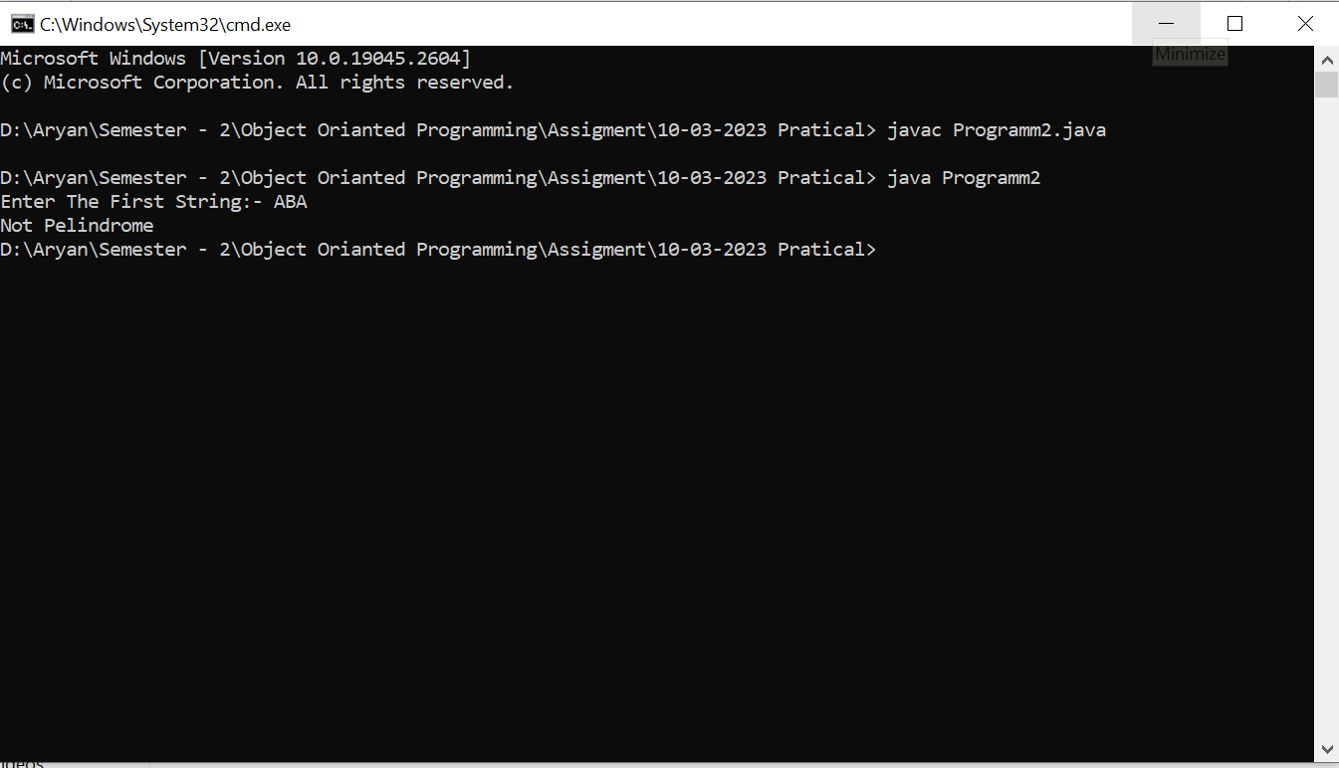

**Experiment: 3**

**Aim:** Write a java program to find the Fibonacci series using recursive Functions.

**Software:** VS Code

**Code:-**

import java.util.* ;

public class Programm3

{

    public static void main(String args[])

    {

        Scanner sc =new Scanner (System.in);

        int num,a=0,b=1;

        System.out.println("Enter Till How Many Terms You Want The Fibonacci Series?");

        num = sc.nextInt();

        System.out.print(0 + " " + 1 + " ");

        int c = Fibonacci(a,b,num);

        System.out.print(c + " ");

    }

    public static int  Fibonacci(int x,int y,int num)

    {

        num--;

        int z=x+y;

        if(num<=2)

        {

            return x + y ;

        }

        else

        {

            System.out.print(z + " ");

            return  Fibonacci(y,z,num) ;

        }

    }

}

**Output:**

